Prediction analysis on Bushfires data

I have considered data of bushfire and weather data merged with based on location and date. This data has 44 columns out which I have selected state and suburb specific to Victoria state.

First I have selected below shown variables in to a data frame.

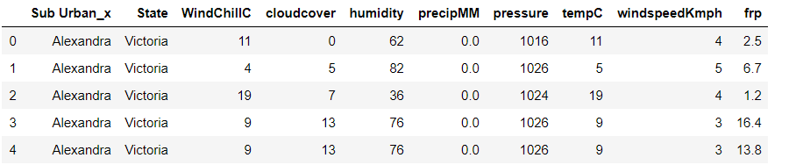

After this I tried to find any correlation between the variables which could cause multi collinearity between them.

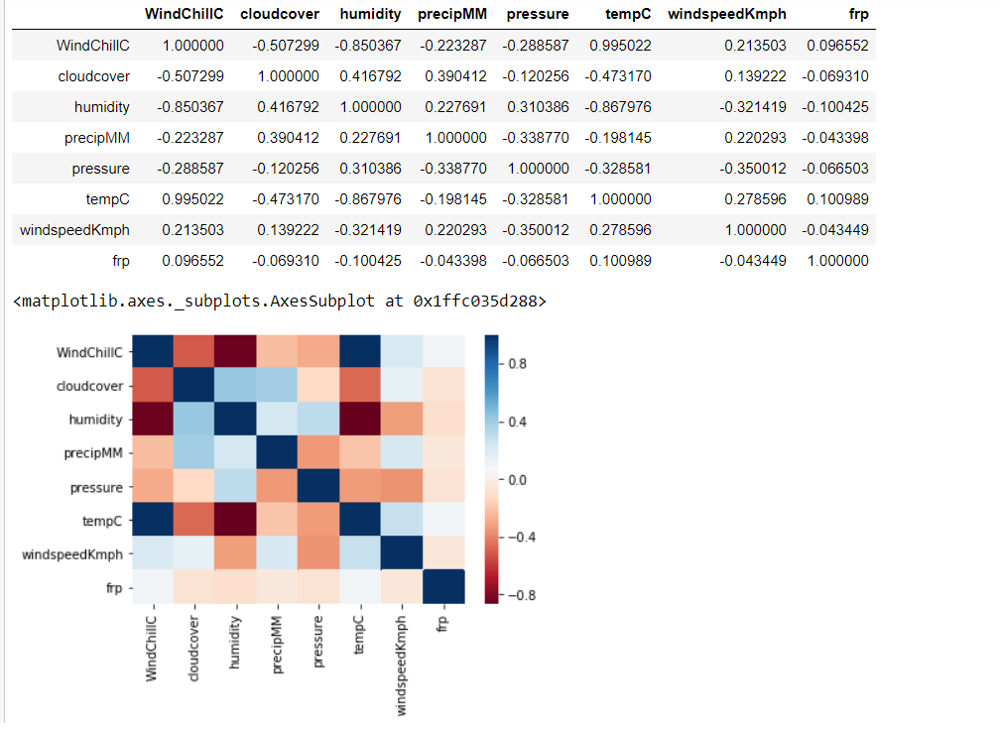

I was able to find that tempc and windchill are correlated so I have considered temperature as windchill has weaker relationship with dependent variable FRP.

After this I was able to see the relation between variables in below matrix.

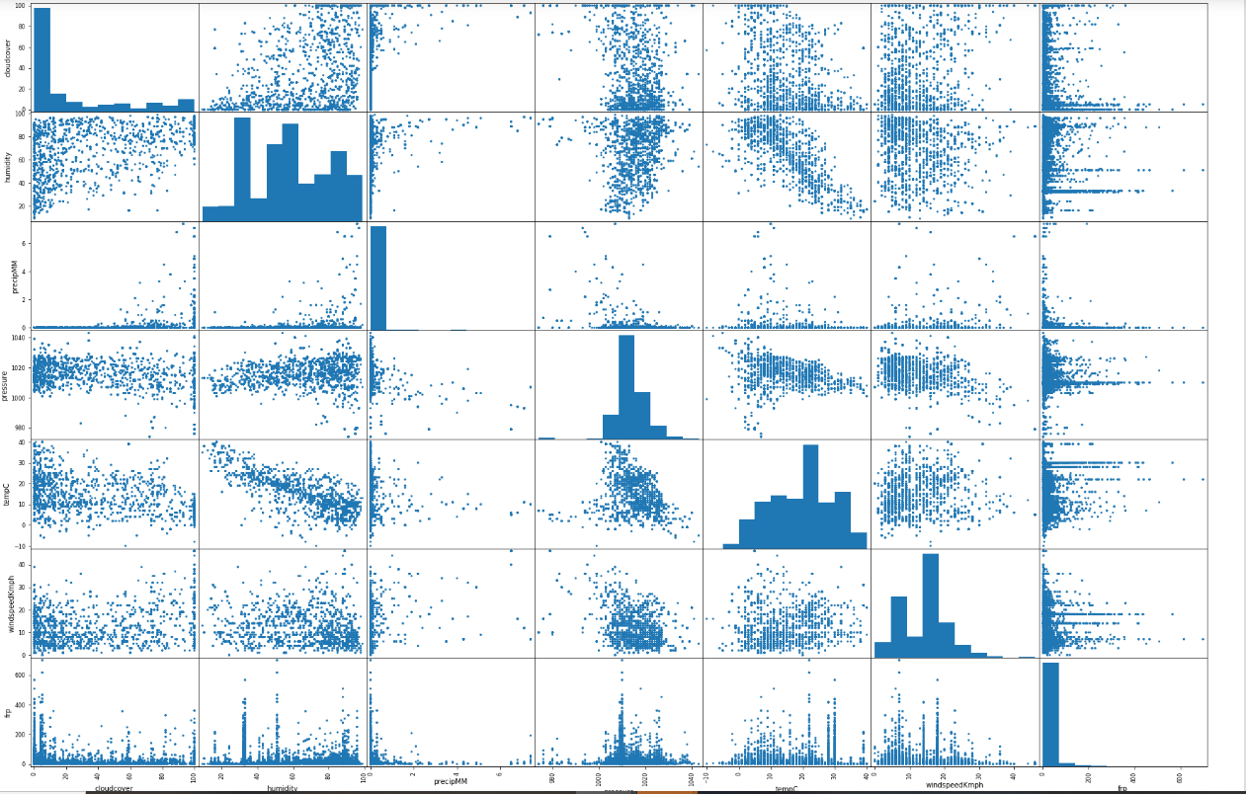

After passing data to modelling multi linear regression we have got the coefficients and intercept as below

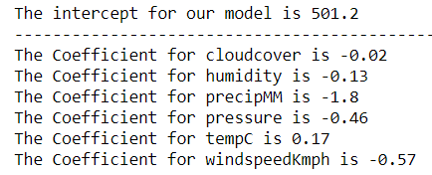

Mean square error and root mean square error were shown below.

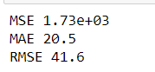

Finally the r square value is 0.018 which is not happy value so I have reject this model based on the R square value.